  - Postalloy® Hardfacing Products for the Agricultrual Industry
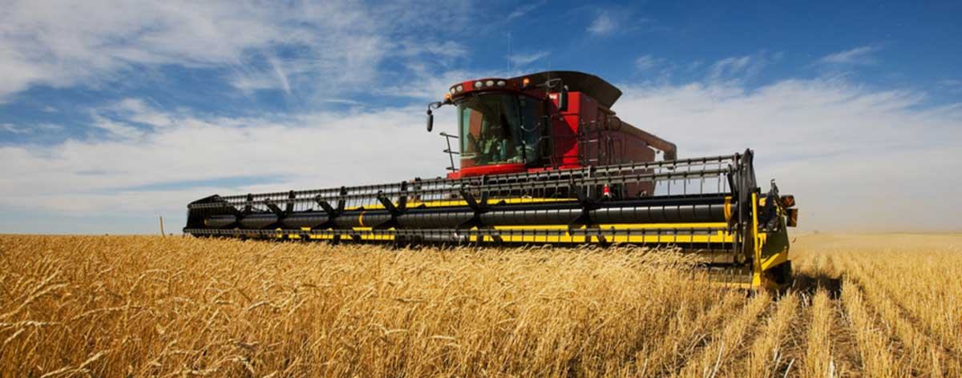

Overlay Hardfacing Wires
Postalloy® DuraHard™2829-MCO is a high hardness overlay well suited for applications involving high abrasion combined with mild impact. Average Hardness is 64-68 Rc.
Applications include Alfalfa mill hammers, Ammonia injector feet, Bean knives, Brush shredder teeth, Corn stalker cutter blades, Grain disc’s, Grain hammers, Lister shares, Plow mold boards, Rotary hoe teeth, Spring teeth runners.

Postalloy® DuraChrome™2832-MCO is a premium chromium carbide hardfacing alloy that has a high-volume fraction of carbides dispersed in a hard matrix. For applications involving high abrasion and mild or moderate impact. Average Hardness is 58-62 Rc.
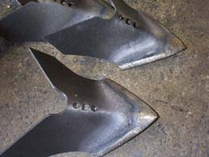
Applications include Alfalfa mill hammer, Ammonia injector feet, Bean knives, Beet puller points, Brush shredder teeth, Cane knives, Cultivator sweeps, Disc’s, Ensilage cutter bars and knives, Grain discs and hammers, Hay chopper knives, Lister shares, Plow mold boards, Post hole diggers, Potato digger, Rasp bars, Root cutters, Rotary hoe teeth, Shredders & fibrizer hammers, , Spike harrow teeth, Spring teeth runners, Subsoil teeth.

Postalloy® DuraChrome™2837-MCO is specifically designed to produce a high concentration of fine chromium carbides in an austenitic matrix. The fine dispersion of chromium carbides greatly improves the abrasive wear resistance and impact toughness compared to ordinary chromium carbide products. DuraChrome™ 2837-MCO can be applied to carbon steels, low alloy steels, manganese steels and cast-iron rolls. Very consistent crack pattern makes DuraChrome™ 2837-MCO an excellent choice for multi-layer hardface applications. This helps reduce the probability of spalling and chipping. The weld

deposit is not machinable and will withstand hot wear applications up to 1000°F (538°C). Average hardness is 60-66 Rc.
Applications include Sugar mill rolls (Chapisco), Beet puller points, Brush shredder teeth, Cane drum fingers, Cane knives, Cane trash discs, Colter’s, Corn planter runners, Corn stalk cutter blades, Ensilage knives, Hay chopper knives, Lister shares, Post hole diggers, Rotary hoe teeth, Spike harrow teeth, Subsoil teeth, Tobacco thresher teeth.

Postalloy® DuraHard™2899-FCO is a general-purpose flux-cored, open arc hardfacing wire providing a good combination of abrasion resistance and toughness. Average hardness is 50-59Rc.
Applications include Clearing rakes and blades, Corn picker runners, Corn planter runners, Corn stalk cutter blades, Grain discs, Potato diggers, Rasp bars, Root cutters

Electrodes
Postalloy® 214 is a high chromium carbide hardfacing electrode for high abrasion and mild impact applications. Deposits take on a high polish, producing excellent frictional and sliding abrasion resistance. Use on carbon and alloy steels, stainless steels and cast iron. Postalloy® 214 is highly resistant to heat and corrosion. Corrosion resistance is equal to straight chromium steels, and it retains its hardness up to 1000°F(538°C). Postalloy® 214 offers good out-of-position welding characteristics on either AC or DC. It offers fast deposition rate and easy slag removal. It produces minimum dilution for high first past hardness and deposits are extremely smooth and virtually ripple free. Average hardness is up to 60Rc.
Applications include Farm implements, Shredders &fibrizer hammers, Hay chopper knives, Subsoiler teeth.

Postalloy®215HD is a chromium carbide tubular hardfacing electrode with extremely good abrasion resistance coupled with mild to moderate impact resistance. Average hardness is 58-62 Rc.
Applications include Alfalfa mill hammer, Ammonia injector feet, Bean knives
Colter’s, Corn planter runners, Hay chopper knives
Potato digger, Shredders & fibrizer hammers, Subsoil teeth.

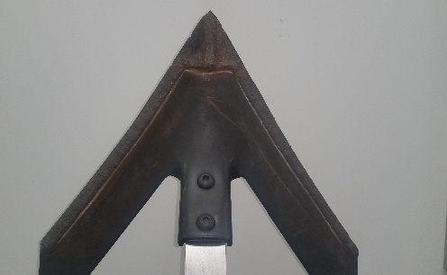
Postalloy® BT Chromalloy is a chromium carbide bare tubular rod for oxy-acetylene applications. It is an ideal solution for extreme metal to earth applications. It offers excellent abrasion resistance with mild or moderate impact. It is well suited for applications requiring thin deposits. Excellent for application to tillage tools. It can be applied to carbon, low alloy, and manganese steels. Can be used in hot wear applications up to 900°F (482°C) . Average hardness is 58-62 Rc.
Applications include Tillage Tools, Plow shares, Sweeps, Sand Chutes, Subsoiler blades.
www.hardfacetechnologies.com
5500 West 164th Street Cleveland, OH 44142 USA Phone: (216) 265-9000 Fax: (216) 265-9030
Mike Korba mkorba@postle.com

