  - Postalloy® Hardfacing Products for the
  - Construction Industry
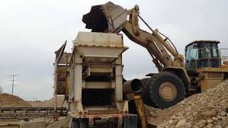

Overlay Hardfacing Wires

Postalloy® 2829-MCO is a high hardness overlay well suited for applications involving high abrasion or abrasion combined with mild impact. Average hardness is 64-68 Rc
Applications include Asphalt mixer blades, Compactors, Curbing machine augers, Paving machine agitator blades, Paving machine paddles, Paving machine screw augers, Post hole augers, Tamper tools.

Postalloy® DuraChrome™2832-MCO is an open-arc or gas shielded premium chromium carbide for applications involving high abrasion and mild or moderate impact.
Average hardness is 58-62Rc.
Applications include Auger flights, Bulldozer blades, Screw conveyors, Mixer blades, Hammers.

Postalloy® DuraChrome™2837-MCO is specifically designed to produce a high concentration of fine chromium carbides in an austenitic matrix. The fine dispersion of chromium carbides greatly improves the abrasive wear resistance and impact toughness compared to ordinary chromium carbide products. DuraChrome™ 2837-MCO can be applied to carbon steels, low alloy steels, manganese steels and cast-iron rolls. Very consistent crack pattern makes DuraChrome™ 2837-MCO an excellent choice for multi-layer hardface applications. This helps reduce the probability of spalling and chipping. The weld deposit is not machinable and will withstand hot wear applications up to 1000°F (538°C). Average hardness is 60-66 Rc.
Applications include Screw conveyors, Chutes and liner plates, Hammers
Crusher Parts, Cement crusher rolls.
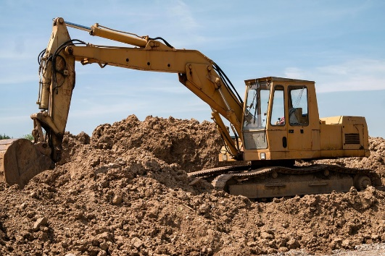

Postalloy® DuraHard™2898-FCO is a low chromium general purpose self-hardening overlay with a good combination of resistance to abrasion and impact. It is very tough with excellent resistance to chipping and spalling. Average Hardness is 55-59 Rc.
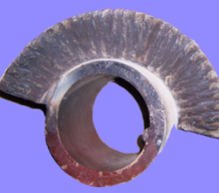
Applications include Hot shear blades, Dozer blades, Tamper feet, Bucket teeth.

Build-up Hardfacing Wires
Postalloy® DuraMang™2865-FCO is a flux-cored open-arc hardfacing wire that deposits fully austenitic chromium-manganese weld metal. Hardness as deposited 20Rc, work hardens up to 45-55Rc
Applications include Pulverizing hammers, Crusher rolls and jaws

Overlay Hardfacing Electrodes
Postalloy® 214 is a high chromium carbide hardfacing electrode for high abrasion and mild impact applications. Deposits take on a high polish, producing excellent frictional and sliding abrasion resistance. Use on carbon and alloy steels, stainless steels and cast iron. Postalloy® 214 is highly resistant to heat and corrosion. Corrosion resistance is equal to straight chromium steels, and it retains its hardness up to 1000°F(538°C). Postalloy® 214 offers good out-of-position welding characteristics on either AC or DC. It offers fast deposition rate and easy slag removal. It produces minimum dilution for high first past hardness and deposits are extremely smooth and virtually ripple free. Average hardness is up to 60Rc.
Applications include Augers, chutes and liner plates, shredders & fibrizer hammers

Postalloy®215HD is a chromium carbide tubular electrode with extremely good abrasion resistance coupled with mild to moderate impact resistance. Average hardness is 58-62Rc.

Applications include Screw conveyors, Chutes and liner plates, Hammers

www.hardfacetechnologies.com
5500 West 164th Street Cleveland, OH 44142 USA Phone: (216) 265-9000 Fax: (216) 265-9030
Mike Korba mkorba@postle.com

