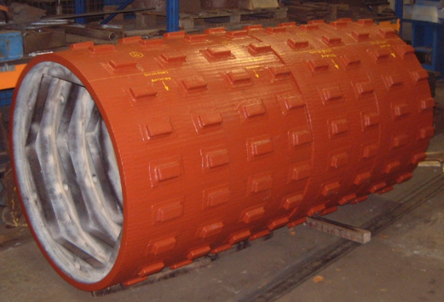
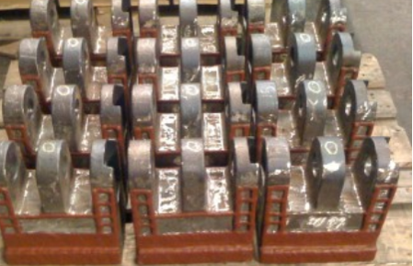
  - Postalloy® General Hardfacing Products
Overlay Hardfacing Wires
Postalloy® DuraChrome™2820-MCO is an open-arc or gas shielded chromium carbide alloy for applications involving high impact combined with abrasion. Weld metal is tougher than conventional chromium carbide alloys with fewer stress relieving cracks. Average hardness is 47-52Rc.
Applications include Final overlay on crusher jaws, Cone and roll shells, Crusher Parts, hammer mill hammers, High impact, and high abrasion applications.

Postalloy® 2829-MCO is a high hardness overlay well suited for applications involving high abrasion combined with mild impact. Average Hardness is 64-68 Rc
Applications include Tiller tools, mixer paddles, tamper tools, log grapples, rakers, hammers, augers, side plates.

Postalloy® DuraChrome™2832-MCO is an open-arc or gas shielded premium chromium carbide for applications involving high abrasion and mild or moderate impact.
Average hardness is 58-62Rc.
Applications include Scrapper blades, Auger flights, Bulldozer blades, Screw conveyors, Mixer blades, Hammers

Postalloy® DuraHard™2898-FCO is a low chromium general purpose self-hardening overlay with a good combination of resistance to abrasion and impact. It is very tough with excellent resistance to chipping and spalling. Average Hardness is 55-59 Rc.
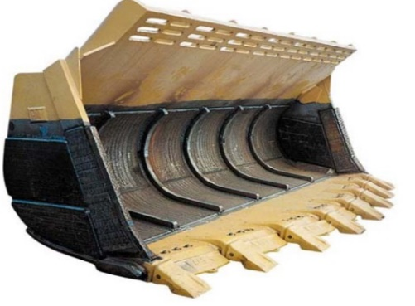
Applications include Hot shear blades, Dozer blades, Tamper feet, Bucket teeth, Farm implements

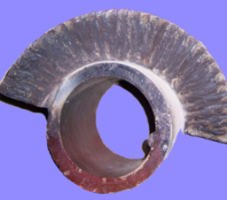
Build-up Hardfacing Wires
Postalloy® DuraMang™2865-FCO is a flux-cored open-arc hardfacing wire that deposits fully austenitic chromium-manganese weld metal. Hardness as deposited 20Rc, work hardens up to 45-55Rc
Applications include Pulverizing hammers, Crusher rolls and jaws

Postalloy® DuraBuild™2892-FCO is a medium hardness buildup wire with excellent compressive strength. Recommended for applications where weld deposits must provide good metal-to-metal wear resistance, but still be machinable “as welded”. Average Hardness is 30-35 Rc.
Applications include Machine components, Gear teeth and keyways, Undercarriage idlers and rollers

Overlay Hardfacing Electrodes
Postalloy® 214 is a high chromium carbide hardfacing electrode for high abrasion and mild impact applications. Deposits take on a high polish, producing excellent frictional and sliding abrasion resistance. Use on carbon and alloy steels, stainless steels and cast iron. Postalloy® 214 is highly resistant to heat and corrosion. Corrosion resistance is equal to straight chromium steels, and it retains its hardness up to 1000°F(538°C). Postalloy® 214 offers good out-of-position welding characteristics on either AC or DC. It offers fast deposition rate and easy slag removal. It produces minimum dilution for high first past hardness and deposits are extremely smooth and virtually ripple free. Average hardness is up to 60Rc.
Applications include Augers, chutes and liner plates, shredders & fibrizer hammers

Postalloy®215HD is a chromium carbide tubular electrode with extremely good abrasion resistance coupled with mild to moderate impact resistance. Average hardness is 58-62Rc.

Applications include Screw conveyors, Chutes and liner plates, Hammers

Build-up Hardfacing Electrodes
Postalloy® 207 is a high alloy, work-hardening austenitic manganese steel hardfacing electrode. It can be used equally well for joining and buildup/surfacing of carbon, low alloy, and manganese steels. Weld deposits made with Postalloy® 207 are a modified chromium-manganese chemistry providing an excellent combination of weld metal strength and ductility. Work-hardens rapidly under repeated impact. The yield strength is higher than ordinary manganese alloys providing greater resistance to mushrooming when subjected to compressive loads and repeated impact. Ideal as a cushioning or buffer layer on manganese steel parts that must be rebuilt on a repetitive basis. Since it will not embrittle until 1000°F (538°C), it will act as an insulator to the manganese base metal in helping it keep below 500°F (260°C) during the welding operation. Hardness as deposited is 20Rc and work hardens to 45-55Rc.
Applications include Fabricating manganese steels, Crusher pads, Cones and roll shells, grizzly bars, sizing screens
www.hardfacetechnologies.com
5500 West 164th Street Cleveland, OH 44142 USA Phone: (216) 265-9000 Fax: (216) 265-9030
Mike Korba mkorba@postle.com

