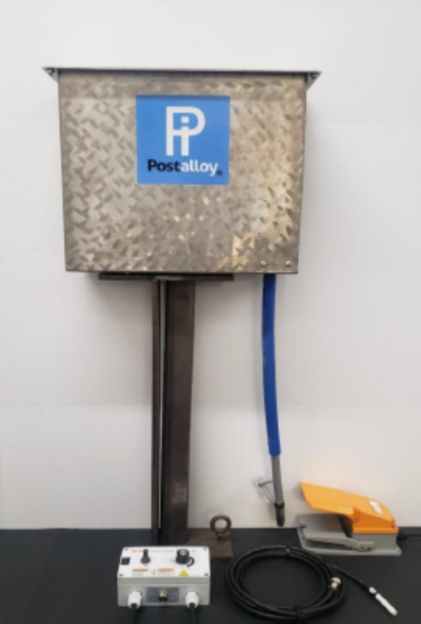
  - Postalloy® Tungsten Carbide Hardfacing Products

DURAMAX Tungsten Carbide Embedding System

The Postle DURAMAX tungsten carbide feeder is used to deliver tungsten carbide into the molten weld pool while using the GMAW process. Typically, 0.045” or 1/16” wire diameters of PS98WC Matrix are used using the GMAW process and 98Ar/2O shielding gas to overlay steel with a wear resistant embedded coating of tungsten carbide.

The tungsten carbide is put into the top of the carbide feeder hopper where it is transported using a vibratory system into a lower hopper. The hopper dispenses the carbide through the blue tube which is attached to the welding gun shroud by means of a bracket and clamp. There is a dial for adjusting the power output going to the tungsten carbide feeder.

Postalloy® PS98WC Matrix hardfacing wire, alloyed with chromium and molybdenum is developed primarily to be used in conjunction with the MIG Carbide Embedding process. PS98WC Matrix provides a clean, molten, and fluid weld bead that readily accepts tungsten carbide grit. Improves the performance of MIG Tungsten Carbide embedded parts.
Hardness of 55-59Rc protects the tungsten carbide grit which has a hardness more than 75Rc. The molten weld results in an even distribution of carbide particles throughout the entire weld deposit.

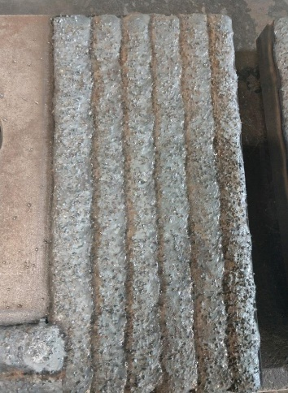
Unlike soft metal steel welding wires which are commonly used with the MIG Carbide Embedding Process, the high hardness tool steel micro-structure of Postalloy® PS98WC Matrix is designed to encapsulate and protect the carbide particles from premature erosion. Use on carbon, low alloy steel and manganese steel.
Applications include Grader blades, Bulldozer blades, Excavator parts, Dredge cutter teeth, Tunneling equipment, Auger teeth, Woodchippers, Hammers for recycling Wood-waste, Asphalt shingle recycling equipment, Waste processing systems Tub grinders.
Tungsten Carbide Wires
Postalloy® TungGuard™ PS-11W with Reactive Core Technology™ (RCT) is a non-cracking nickel base hardfacing cored wire containing a special blend of tungsten carbides for extreme abrasion as well as corrosion. The matrix is resistant to acids, bases, lye, and other corrosive media. This alloy can be applied crack-free with the proper welding procedures. The alloying elements in the wire produce a higher hardness weld deposit that encapsulates and protects the carbide particles, reducing the premature wear caused by erosion to the carbide particles. As a result, it achieves a considerable service life improvement in extreme applications compared to PS-10 which it has replaced. The alloy has a low melting range and features good weldability with a smooth arc, reduces weld dilution and carbide dilution to produce a truly outstanding multi-wear wire. Use on low carbon mild and low alloy steels, stainless, nickel and cast iron. Average Weld Deposit Hardness : 53-57Rc. Average Hardness Tungsten carbide: 2300 - 2500 HV (70 Rc+)
Applications include Repairing and hardfacing ferritic and austenitic stainless-steel tools in the Chemical and Food Industries, Mixer blades, Tunnel boring machines, Fan Blades, Screw Conveyors. Developed for application to downhole tools in the deep oil and gas drilling industry, such as stabilizers.
Postalloy® TungGuard™ 299-MCO is an open-arc hardfacing overlay that utilizes a specially formulated tungsten carbide to produce a "highly feathered" microstructure that is unusually hard and more abrasion resistant than standard tungsten carbide hardfacing wires. Operates at lower-than-normal currents to minimize dilution and help develop its high hardness and unique microstructure in the first layer. For extreme earth abrasion resistance with little or no impact. Average Hardness is 64-68 Rc. Applications include Scraper blades, Bulldozer blades/end bits, Grader blades/bits, Stabilizers Mixer screws, Feed screws, Fan blades, Concrete mixer paddles.
Postalloy® Vanguard™ PS-150-MCO is a metal-cored hardfacing wire that provides a dense, heterogeneous deposit of vanadium - tungsten carbides, along with other elements to enhance wear resistance, resulting in a very good combination of abrasion and impact resistance that is superior to chromium carbide hardfacing alloys. Almost equal to tungsten carbide in hardness, and half the weight. Vanguard™ PS-150 is not a replacement for tungsten carbide overlays. However, it is a good alternative to tungsten carbide hardfacing alloys when they are too expensive or when MIG carbide embedding is not available or impractical. Average hardness is 59-61Rc. Applications include stabilizers, recycling wear parts, debarking hammers. (Also available in a Tubular Electrode, PS-150HD Vanguard)

Tungsten Carbide Tubular Electrode
Postalloy® 220HD is a proprietary blend of tungsten carbide with a small addition of chromium carbide. It produces a very smooth weld deposit with improved impact resistance over pure tungsten carbide. The unique blend of tungsten carbide in a chromium rich matrix also provides some corrosion protection but primarily helps to provide a high polish in service to reduce the coefficient of friction. When protection against severe abrasion, with limited impact, is needed, POSTALLOY® 220HD is an ideal choice. Average Hardness is 64-68 Rc. Applications Include: Conveyor screws and augers, cutter and dredge teeth, mixer paddles and blades, shredder and anvil knives, bucket pin ends, coal and cement fan.

www.hardfacetechnologies.com
5500 West 164th Street Cleveland, OH 44142 USA Phone: (216) 265-9000 Fax: (216) 265-9030
Mike Korba mkorba@postle.com

